The Graduate Handbook
Department of Women’s, Gender, and Sexuality Studies Website: wgss.la.psu.edu
Penn State University

Department Head: Dr. Alicia C. Decker (acd207)
Director of Graduate Studies: Dr. Maha Marouan (mzm24)
Graduate Staff Assistant: Ashley Scott (ams87)
Department Location: 345 Willard Building Main Office Phone: 814-863-4025

Welcome to the Department of Women’s, Gender, and Sexuality Studies (WGSS) at Penn State University!

If you are reading this, you are either a new or returning student to the WGSS graduate program, or a graduate minor – or you’re interested in becoming one of those students! This handbook is for you.

Please read this handbook as a starting point for navigating our graduate program, and do not hesitate to contact the Director of Graduate Studies, Dr. Maha Marouan (mzm24@psu.edu; 814-867-6249), if you have questions.

**Please note: This handbook does not address the current COVID situation on campus, which obviously affects each and every one of us. Policies and circumstances are so fluid that we recommend that you visit the University’s dedicated webpage https://virusinfo.psu.edu, as well as the Graduate School’s webpage, https://gradschool.psu.edu/covid19/.

CONTENTS
This WGSS Graduate Handbook is an essential overview to the workings of the Department of Women’s, Gender, and Sexuality Studies and its unique degree programs. Its contents include:

ABOUT THE GRADUATE PROGRAM IN WGSS

- WGSS Today 5
- Learning Outcomes 6
- The Graduate Program “Main Office” 8
  - Who’s Who: Program/Office Staff Roles 8
  - The Grad Lab (Willard 336) 9
- The Graduate Faculty 9
WGSS DEGREE PROGRAM REQUIREMENTS
- WGSS PhD Requirements 10
  - Core courses 10
  - Benchmarks 10
  - Exam and Thesis Committees 11
- WGSS MA/MS Requirements 12
  - Core courses 12
  - The MA Thesis 13
- The Graduate Minor 13
ADMISSIONS TO THE WGSS DUAL-TITLE PROGRAM IN WGSS
- The Process 15
  - For “external” candidates applying to Penn 16
State for the first time as a grad student
  - For “internal” candidates already 16
At Penn State
WGSS GRADUATE PROGRAM PLANNING 17
- Scheduling your classes 17
- Advising and Mentoring 18
- Keeping on Track: The Annual Review 18
- Teaching Opportunities and Funding 18
  - TA-ships 18
  - How to Apply for TA ships 18
  - Residential and online teaching 19
  - Summer Teaching 19
  - Teaching Mentorship 19
  - Awards and Additional Funding 20
  - Departmental Awards 20
  - Conference Travel 20
- Approaching the Job Market 21
- University Graduation 21

DEPARTMENTAL LIFE: BUILDING COMMUNITY 22
- GWGSS (Graduates of WGSS organization) 22
- GADI (Graduate Alliance/Diversity&Inclusion 22
- WGSS Grad Student Listserv 23
- TGIF Newsletter 23
- WGSS Department Meetings 23
- WGSS Coffee Hour and Special Events 23
- Professional Development Opportunities 23
- Your Health and Safety 23
  - “The Red Folder” 23
  - Emergency Funding 24
  - Food and Housing Security 24
- Diversity and Inclusion Resources 24
- Gender Equity Center 25
- Appendices (A-F) 26
  - Appendix A: Current Graduate Faculty 26
  - Appendix B: WGSS Advising Worksheet 31
  - Appendix C: Annual Graduate Studies 33
Dual-title Progress Report
  - Appendix D: Add Graduate Minor Form 34
  - Appendix E: Academic Centers of Interest 35
  - Appendix F: The Red Folder 37

ABOUT THE GRADUATE PROGRAM IN WOMEN’S, GENDER, AND SEXUALITY STUDIES (WGSS)
The History of Women’s and Gender Studies at Penn State

In 1871, the Agricultural College of Pennsylvania—now Penn State University--became the first college in Pennsylvania to admit women to degree programs on a regular basis and was among the first land-grant schools in the nation to do so. Over one hundred years later, WGSS is a thriving, interdisciplinary department that is ranked among the best in the country. We are one of a mere handful of U.S. universities offer a dual-title degree program in WGSS.

WGSS Today

Today, WGSS is located in the College of the Liberal Arts and our central departmental offices are on the third floor of Willard Building on central campus. Our highly diverse, interdisciplinary faculty engage in first-class research, pedagogy, and service with a deep commitment to social justice. Our faculty include feminist scholars from the fields of African Studies, African-American Studies, Art Education, Communication Arts and Sciences, Comparative Literature, English, French and Francophone Studies, Geography, History, Italian, Mass Communications, Philosophy, Political Science, Psychology, Religious Studies, Rural Sociology, Spanish, and more. Thus WGSS students come from five different colleges (Arts & Architecture, Liberal Arts, Earth and Mineral Sciences, Education, Communications) across the University.

We currently offer three dual-title degree options:

- Dual-Title MA/MS Degree
- Dual-Title PhD
- The Graduate Minor

As a vibrant community of scholars and students, the Department of Women’s, Gender, and Sexuality studies is committed to the interdisciplinary, intersectional, and transnational analysis of gender’s relationship to power and social inequality. We deploy interdisciplinary feminist approaches to knowledge production, pedagogy, and community engagement. Our faculty and graduate students work on diverse research topics across the arts and sciences, linking Women’s, Gender, and Sexuality Studies (WGSS) to multiple units across the university

The master’s and doctoral degree programs in Women’s, Gender, and Sexuality Studies, as well as the graduate minor, have allowed us to build a nationally and internationally recognized graduate program. The innovative dual-title degree program provides many scholarly and professional opportunities for our graduate students. With our strong institutional relationships with partner PhD-granting programs and their faculty, as well as numerous affiliate or “courtesy” faculty throughout Penn State, WGSS has achieved unparalleled depth and breadth of faculty expertise. Thanks to this large network of cross-disciplinary faculty, you can expect to receive excellent training in two major fields of study, contextualizing and challenging sexism, homo- and transphobia, ableism, classism, and racial oppression. Our students learn through the development of critical and analytical skills, creative approaches to problem solving, and the ability to articulate productive socio-political alternatives.

In addition, WGSS at Penn State has been highly successful at placing graduates in both academic positions and in a variety of professional and research positions.

We currently partner with thirteen departments from across the university: Art Education; Communication Arts and Sciences; Comparative Literature; Curriculum and Instruction; English; French and Francophone Studies; Geography; History; Mass Communications; Philosophy; Political Science; Psychology; and Rural Sociology.

LEARNING OUTCOMES

Each department at Penn State is required to develop program learning outcomes and assessment procedures. In WGSS, these include the following:

- Demonstrate deep conceptual and historical understanding of intersectional feminist theory and methods;
- Apply current feminist literature from their partner discipline to their own research agenda;
- Comprehend the conceptual and practical dimensions of feminist pedagogy
- Formulate and execute an independent research project that significantly furthers knowledge and theory within interdisciplinary feminist scholarship;
- Communicate effectively conceptual and methodological arguments in both written and oral formats to interdisciplinary audiences;
- Exhibit a commitment to professional standards and ethics in teaching, research, and service.

You should strive to meet all these objectives as you complete your coursework for the degree, sit for your qualifying and comprehensive exams, develop your dissertation proposal, and write and defend your dissertation.

THE GRAD PROGRAM “MAIN OFFICE” @ 345 Willard
The entire third floor is open from 7:30 am on; after 5:30 pm, card swipe must be used to access the floor. If you have questions about access to this floor, contact the main office.

Who’s Who? Program And Office Staff and Their Roles

The Department Head: Dr. Alicia Decker (acd207) has authority over all areas of departmental administration, programming and policy-making. Office Location: 342 Willard.

The Director of Graduate Studies: Dr. Maha Marouan (mzm24) oversees, along with the department head, the direction and administration of the graduate program. In addition, the director handles general advising for students, providing guidance on degree requirements, monitoring student progress each year, assisting in the composition of examination committees and mentoring committees, approving elective courses toward the degree or the minor, and, finally, certifying that requirements are met for graduation. Office Location: 331 Willard.

The Graduate Matters Committee oversees the admissions process into the programs, evaluates graduate teaching applications, and generally seeks to develop or clarify policies that relate to the successful running of the graduate program. They also develop graduate curriculum and policy agendas for the Department, with consultation and final approval by the entire faculty.

The Graduate Matters Committee selects recipients or makes nominations for graduate student awards.

The Graduate Staff Assistant maintains graduate student records and handles paperwork required at various stages of the graduate program. This staff person is responsible for administering the class schedule, credit approvals, and other matters related to the Graduate School and Registrar’s Office. Office Location: 345C Willard

Members of “the Main Office” (345 Willard) Melissa Hummel, Administrative Coordinator 345B Willard Building
(814) 867-2760
mjc7030@psu.edu

Jacqueline (“Jackie”) Cauley, Administrative Support Coordinator (814) 863-1173
jmc671@psu.edu

**Ashley Scott, Administrative Support Assistant for the Graduate Program
(814) 863-4025
ams87@psu.edu

Johey Verfaille, Events Coordinator (814) 867-4561
juv12@psu.edu

The Grad Lab is located in Willard 336. There are computers and a printer for grad student use. Graduate students may also use the large printer in 345 for WGSS business-related printing and copying only. The Grad Lab is open M-F, from 7:30a.m. to 5:30 a.m.

THE GRADUATE FACULTY
A complete list of the Graduate Faculty in WGSS can be found here: http://www.gradschool.psu.edu/gs/faculty/facultylist.cfm?program=177&srch=true. See also Appendix A.

WGSS DEGREE PROGRAM REQUIREMENTS

THE CURRICULUM IN WGSS: PHD REQUIREMENTS

Students must complete 18 credits of WGSS coursework. For incoming students who are new to Penn State, consult the DGS as your adviser during your first fall semester. This DGS can help facilitate your connections to our faculty and guide you in the field until you identify a field-specific adviser.

Required Core Courses:

- WMNST 502: Global Perspectives on Feminism (3 credits)
- WMNST 507: Feminist Theory (3 credits)
- WMNST 508: Feminist Methodologies (3 credits) or WMNST 509: Feminist Pedagogies (3 credits)

Students must also complete 9 additional credits of WGSS coursework (at least 6 of which should be at the 500 level) chosen in consultation with the Women’s, Gender, and Sexuality Studies DGS. At least three of those credits must be offered by a department other than your disciplinary-major program.

Please note that any seminar not formally cross-listed with a WMNST course abbreviation must be approved by the WGSS Director of Graduate Studies to count toward your dual-title or minor. See the advising form (Appendix B), which summarizes course requirements.

Benchmarks for the PhD

- Completion of Core Courses (9 Cr)
- Completion of Elective Courses (9 Cr)
- Qualifying Exams
- Comprehensive Exams
- Dissertation Proposal and Defense
  - The student’s dissertation topic must be related to the interdisciplinary field of Women’s, Gender, and Sexuality Studies

EXAM AND THESIS COMMITTEES, COMPOSITION OF
(See GCAC-602 PhD Committee Formation, Composition, and Review - Research Doctorate).

Dual-Title PhD Qualifying Exam Committee

Whenever possible, at least one WGSS faculty member should participate in the qualifying exam process. Some considerations:

  - Some partner departments require standardized exams for all students, so WGSS participation is not always possible. If that is the case, WGSS committee members can require an additional WGSS-focused qualifying exam. Students should clarify expectations with WGSS committee members and the WGSS DGS as soon as possible.

  - Because students may require an additional semester to fulfill all requirements, the qualifying exam may be delayed one semester beyond the normal period allowable. However, the Graduate School has determined that qualifying exams must be completed by the end student’s fourth semester. Any exceptions to that MUST be approved in advance by the Graduate School!

Dual-Title Ph D. Comprehensive Exam Committee

WGSS faculty members must participate fully in the comprehensive exam process, and the exam must include questions on feminist theory and methods. Your chair/co-chair should be in touch with the partner department to ensure that all faculty understand the format and are involved in the development of the exam.

The Graduate School requirement for an “outside field” member on the doctoral committee can be filled by the WGSS faculty on the committee. All doctoral committees at Penn State must also have an “outside unit” member (someone with a different tenure home than the chair or co-chair). It is possible for one person on the committee to fulfill both roles—as both an outside field and outside unit member.

Please work with the DGS—of both your departments—to help you navigate Grad School and departmental requirements in the composition of your committee.

Dual-Title Doctoral Thesis Committee

At least two Graduate Faculty of WGSS must be included on your doctoral committee. One of these two WGSS members must serve as either chair or co-chair of the doctoral committee.

  - The Graduate School requires that each doctoral committee include an “outside field” member (from within a department) and an “outside unit” member (someone with a different tenure home than the chair or co-chair). It is possible for one person on the committee to fulfill both roles—as outside field and outside unit member. That said, we encourage you to ensure that one of the WGSS members of the committee be from outside your partner discipline. This supports interdisciplinary inquiry and training. Please work with us to help you navigate these rules!

For the most up-to-date and detailed description of the required composition of your dissertation committee, please visit the Grad School’s website:

https://gradschool.psu.edu/graduate-education-policies/gcac/gcac-600/gcac-612-phd- committee-formation

THE CURRICULUM IN WGSS: MASTER’S DEGREE PROGRAM REQUIREMENTS

Students must complete twelve (12) credits of WGSS coursework.

Required Courses:

    - WMNST 502: Global Perspectives on Feminism (3 credits)
    - WMNST 507: Feminist Theory (3 credits)
    - WMNST 508: Feminist Methodologies (3 credits) or WMNST 509: Feminist Pedagogies (3 credits)

Students must also complete 3 additional credits of WGSS coursework chosen in consultation with the Women’s, Gender, and Sexuality Studies Graduate Program Director. Please note that any seminar not formally cross-listed with a WMNST course abbreviation must be approved by the WGSS Director of Graduate Studies to count toward your dual-title or minor.

THE MA THESIS

The dual-title MA thesis is a scholarly paper that integrates, theoretically and/or methodologically, both your disciplinary major field, and WGSS.

At least one member of the student’s advising committee must have Graduate Faculty standing in Women’s, Gender, and Sexuality Studies.

THE GRADUATE MINOR (MA AND PHD)HE GRADUATE MINOR (MA AND PHD) IN WGSS

Request to Add Graduate Minor Form (link); see Appendix D.

An interdisciplinary graduate minor in Women’s, Gender, and Sexuality Studies is available to any student currently active in a graduate degree program at Penn State.

Official requests to add a minor to a doctoral candidate's academic record must be submitted to Graduate Enrollment Services prior to establishing the PhD committee and prior to scheduling the comprehensive examination. A simple request form is available from the Graduate School. A student seeking a minor must have the approval of the student's major program of study, the minor program, and the Graduate School.

Doctoral Degree Minor Requirements

Dual-title PhD students wishing to add a minor in WGSS must submit an official request to Graduate Enrollment Services prior to establishing their doctoral committee or scheduling their comprehensive examination.

To earn a PhD minor, students are required to complete 15 credits of coursework in Women’s, Gender, and Sexuality Studies. This includes three required courses: WMNST 502: Global Perspectives on Feminism (3 credits), WMNST 507: Feminist Theory (3 credits), and either WMNST 508: Feminist Methodologies (3 credits) or WMNST 509: Feminist Pedagogies (3 credits). Students must also complete six additional credits of WGSS coursework.

At least one Graduate Faculty member of WGSS must be included on the doctoral minor committee.

Master’s Degree Minor Requirements

To earn an MA minor, students are required to complete 9 credits of coursework in Women’s, Gender, and Sexuality Studies. This includes two required courses: WMNST 502: Global Perspectives on Feminism (3 credits) and WMNST 507: Feminist Theory (3 credits). The additional three credits must be chosen in consultation with and pre- approval from the Director of Graduate Studies in WGSS.

Graduate Minors for Current WGSS Graduate Students

WGSS graduate students may themselves apply for a graduate minor in any department that offers one.

ADMISSIONS TO THE DUAL-TITLE DEGREE PROGRAM IN WGSS
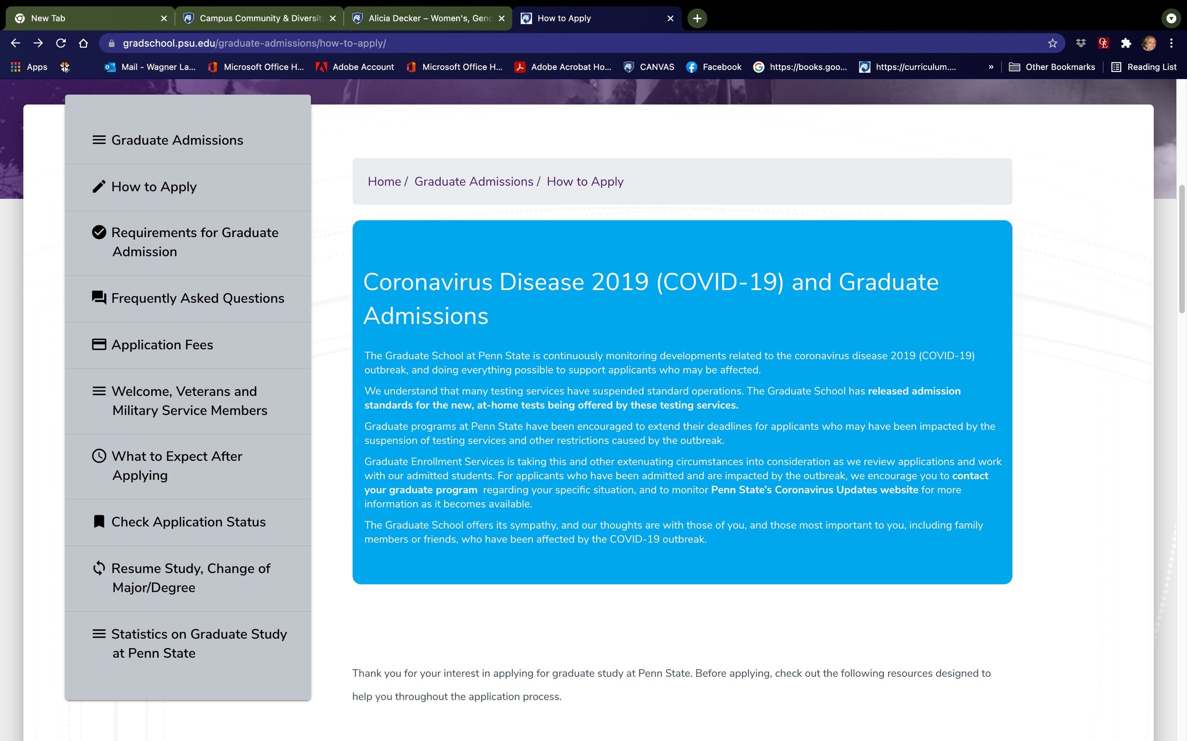

THE PROCESS
https://gradschool.psu.edu/graduate-admissions/how-to-apply/

Applications to the Dual-Title Degree Program in WGSS must be completed online. You can apply for the dual-title program in two ways:

- You can apply to your disciplinary major and to the WGSS inter-disciplinary major at the same time.

- You can apply to WGSS after you have matriculated into one of the 13 disciplinary majors that WGSS has a partner agreement with. CRITICAL TIMING NOTE: As a current student at Penn State you must submit a dual-title application and be accepted before taking qualifying examinations in your disciplinary major department. The Graduate School will not accept applications after qualifying exams have been passed. They have become quite inflexible about this.

Students applying to WGSS concurrently with admission to Penn State:

You will be applying online to the Graduate School at Penn State. As you apply to a disciplinary major (which must be of our thirteen partner programs) you will see a list of dual-title degrees that particular department participates in. When you reach that list, mark your intention to apply also to WGSS. We encourage our partner departments to alert us to any promising WGSS applicants—but the initial admissions decision will come from the disciplinary-major department.

If and when you are admitted into a disciplinary major program (who is also a partner with WGSS), our admissions committee will review your file using the same materials you submitted in that application.

Our admissions committee follows the timetable of our partner departments. You may receive an acceptance from that major program a week or two before receiving our admissions decision; but WGSS does try to move as quickly as possible after we receive the partner department’s final list of acceptances. The DGS of WGSS will communicate our department’s decision to the disciplinary-major department’s DGS—and you will hear from one or both of us at that point.

For Internal Candidates Applying After Matriculation at Penn State:

The admissions committee meets once per semester to review internal applications. The application deadlines for current Penn State students are October 15 and February 15. Master’s degree students can apply at any point in their program, provided they are able to fulfill all requirements before graduation.

Timing is critical! PhD students must apply and be admitted before taking their qualifying exams. We strongly recommend that prospective applicants take one of our required courses before applying (or during the semester they plan to apply). If this is not possible, please explain the circumstances in your personal statement.

Students already enrolled in one of our thirteen partner programs may apply by submitting the following via email to wgssgradprogram@psu.edu:

- A curriculum vitae
  - A list of in-progress and completed WGSS coursework at Penn State
  - Please ask those course instructors to submit a confidential email providing a brief overview of your performance and abilities.

  - A writing sample (ideally from a WGSS-related graduate course)
  - A personal statement that describes how your research and professional goals reflect an interest in interdisciplinary feminist research
  - One (1) letter of recommendation from a member of the Graduate Faculty of the Department of Women’s, Gender, and Sexuality. This faculty member can be the same person who assesses your performance in class, but you may prefer to a different faculty member who is able to your qualifications.

*All applications should clearly explain how your research plans will integrate both your disciplinary major, and the interdisciplinary WGSS major; and also, why/how the dual-title program will enrich your graduate education and career goals.
*Any letters of recommendation from faculty should be submitted directly to wgssgradprogram@psu.edu, or to the DGS.

WGSS GRADUATE PROGRAM PLANNING

One of the most important things to realize as you undertake the WGSS dual-title degree program is that you must follow closely the degree requirements from both the dual-title interdisciplinary WGSS program and your disciplinary-major program. WGSS does not have control over—nor comprehensive knowledge of—a partner department’s curriculum requirements. We seek to make our dual-title program as flexible as possible to allow students to complete all requirements in a timely manner. But for this reason, advising and mentoring are an important aspect of your graduate experience!

SCHEDULING CLASSES

The Spring 2022 Course Registration schedule is as follows:

- Tuesday, September 7, 2021 -- Schedule of Courses becomes available
- Friday, September 17, 2021 -- Pre-Registration Activity Guides become available in LionPATH Student Center
- Wednesday, September 22, 2021 -- LionPATH Enrollment Shopping Carts open for Undergraduate and Graduate Students

ADVISING AND MENTORING

For incoming students who are new to Penn State, the DGS will act as your advisor until a WGSS faculty advisor in your area of study is determined. The DGS and/or faculty member can help facilitate your connections to the rest of our faculty, and guide you in the field. Of course, the DGS is always available to advise you any point as you progress through the program.

KEEPING ON TRACK: THE ANNUAL REVIEW PROCESS
We ask that each dual-title PhD and MA student submit an annual progress report, detailed below.

Most of our partner programs require some form of annual report and/or yearly meeting with one’s advising committee. Your WGSS adviser(s) should be part of that process. They should be invited to this meeting and/or receive a copy of such a report.

By April 1 every spring, each dual-title student should submit in writing an annual progress report form (see Appendix D), signed by you, the student, and your WGSS faculty adviser. Please submit this form via email to WGSSgradprogram@psu.edu as a PDF titled “LASTNAME_FIRSTNAME Annual Report 202X-202X.”

TEACHING OPPORTUNITIES AND FUNDING
Teaching Assistantships: We are pleased to offer a limited number of one-year teaching assistantships, which include tuition, stipend and health insurance, to both dual-title and graduate minor PhD students.

These assistantships provide an additional year of funding and critical professional experience for students. Most TAs will teach one of our introductory courses, such as WMNST 100: Introduction to Women’s and Gender Studies, WMNST 105: Living in a Diverse World, WMNST 106: Representing Women and Gender in Literature, Art and Popular Cultures, or WMNST 245: Introduction to LGBTQ+ Studies.

How to apply: The deadline for the following academic year’s TA assignments is February 15, 2022. The Director of Graduate Studies will send an email to all WGSS graduate students at least one month prior to the deadline. Priority will be given to

those students with all or most of their WGSS coursework completed, as well as previous teaching experience and a thoughtful feminist pedagogical approach.

Residential and online teaching appointments: The Department of Women’s, Gender, and Sexuality Studies also offers teaching appointments, both online and residential, that are not in the form of teaching assistantships (thus they do not carry a tuition waiver nor insurance).

The goal with teaching appointments is to distribute these opportunities fairly while meeting the programmatic needs of the department. Again, we prioritize those students with all or most of their WGSS coursework completed (having passed their comprehensive exams) and with previous teaching experience.

Residential and online teaching appointments that are not teaching assistantships are made on a rolling basis as needed in response to programmatic needs. The DGS will solicit calls for applications when such opportunities become available. Requests for applications will be made via the WGSS department office and vetted by the Department Head.

Summer teaching

There are three summer sessions: the “Maymester” and two summer sessions. Summer teaching is made available as needed. (Numbers vary each summer). Positions are determined by the department head. There is no special application. WGSS Graduate majors and minors are eligible, and teaching experience and SRTE scores (if available) are obviously the priority for selection.

Teaching mentorship

There are several ways of learning about feminist pedagogy and forms of teaching. The department offers WMNST 509 as a formal introduction to feminist pedagogy, and it is offered at least once a year. Separate feminist pedagogy workshops for graduate students and faculty are offered throughout the academic year. These are announced via the grad student listserv.

Because many graduate students will teach on-line courses, the director of online education in WGSS offers workshops in advance of each semester for those who would like advice and tips on teaching remotely.

Your primary faculty advisers can also serve as mentors for your teaching, of course! In addition, the University and Schreyer Honors College offer a variety of training and certificate programs that you can complete. Keep an eye out for announcements of their offerings and deadlines on the WGSS grad listserv.

AWARDS AND ADDITIONAL FUNDING OPPORTUNITIES IN WGSS

We offer three awards yearly to dual-title students. Calls for nomination are made at the beginning of the Spring semester. The deadline for submitting application materials is typically mid-February. We present these awards to their recipients at our spring awards ceremony.

Sara Woods Outstanding Graduate Student Award recognizes excellence in WGSS scholarship.

Sara Woods Outstanding Graduate Student Teaching Award recognizes excellence in WGSS teaching.

Laura Richardson Whitaker Memorial Graduate Fund recognizes excellence in research and supports dissertation-related research expenses of dual-title students.

Conference Travel Funding. While we cannot guarantee support for graduate students in all circumstances, we typically provide funds for dual-title and graduate minor students to present their research at an academic conference oriented toward women’s, gender, and/or sexuality studies. We prioritize presentations at the National Women’s Studies Association meetings and try to set aside funds particularly in support of graduate student participation in this annual conference. Please send your requests to the Director of Graduate Studies, including the following information: the name of the conference; the title of the paper or poster you will present; the relevance of the conference to your professional development in the field of WGSS; and a brief budget detailing the amount of your request (include any funds for the trip already committed from other units or entities). Please send this request well in advance of your departure.

APPROACHING THE JOB MARKET

In addition to speaking with your advisors, WGSS sponsors workshops related to preparation for the job search (constructing a CV, job-letter writing, mock interviews). WGSS workshops focus particularly on how to explain and promote your interdisciplinary work, for individuals who may be unfamiliar with gender studies and feminist thought and methodologies.

UNIVERSITY GRADUATION
During the semester before you plan to graduate, you will file an “intent to graduate” form. To graduate, you must satisfy all the University, college, and major requirements that were in effect at the time of your most recent admission, or re-enrollment, as a degree candidate to the University.

Process:

- It is your responsibility to notify the University of your intent to graduate (policy 86-00).
- Confirm the activation period on the Academic Calendar for the dates when you can activate your intent to graduate.
- Using the "Apply for Graduation" link within the My Academics page in the LionPATH Student Center, you can set your intent to graduate.

For more information, see https://www.registrar.psu.edu/graduation/intent.cfm

DEPARTMENTAL LIFE: BUILDING COMMUNITY
One key strength of our dual-title and graduate minor programs is the extensive network of faculty and graduate students who are engaged in cutting-edge, interdisciplinary feminist scholarship and teaching at Penn State. The size and reach of Penn State’s degree programs in Women’s, Gender, and Sexuality Studies are unparalleled in terms of opportunities for students to take a wide range of graduate courses in the field, to work with an array of world-class advisers, and to interact with a comparatively large cohort of feminist graduate students.

The challenge for students, however, is that they often feel the pull of both programs, and it is not always easy to balance obligations. While recognizing these constraints, we work to maximize student engagement in the life of the department. Such engagement is critical for the intellectual and professional enrichment that WGSS offers and for the feminist-inspired refuge we can provide from other aspects of academic life.

We encourage you to engage the WGSS community from the moment you arrive at Penn State—even if you have not yet decided whether (or not) to formally apply for a dual-title or graduate minor in Women’s, Gender and Sexuality Studies. These are some of the ways you can tap into the activities of the department:

GWGSS: Graduates in Women’s, Gender, and Sexuality Studies. https://sites.google.com/site/pennstatewsgo/home Email: psugwgss@gmail.com

The mission of the GWGSS is to represent and support the interests of graduate students in Women’s, Gender, and Sexuality Studies, as well as those who are interested in or affiliated with the program. GWGSS enriches the experience of graduate students by creating intellectual networks and providing leadership, social, and professional opportunities, as well as ensuring adequate and fair representation of graduate student interests within WGSS. GWGSS accomplishes these goals through various events intended to promote intellectual community both within the graduate student community and between graduate students and faculty. Perhaps the most important of these is the graduate student conference, which is held once every year.

GADI: Graduate Alliance for Diversity and Inclusion
GADI is devoted to supporting graduate students who identify with or are allies to people from underrepresented communities. It brings students together from across

the college’s departments to discuss issues of diversity, provide support to students and education for the community, and build community among graduate students from diverse backgrounds.

Graduate student listserv (l-wgss-grad@lists.psu.edu).
Please email wgssgradprogram@psu.edu to be added to the graduate student listserv at any time after you receive your PSU email account. You can be on the list whether you have formally declared a minor or been accepted into the dual-title program, or even if you will not be doing either but want to hear about our events.

TGIF. A departmental newsletter for WGSS graduate students.

WGSS Department Meetings
Our department meetings are open to graduate students and are held monthly. These meetings provide opportunities to interact with faculty and graduate students and to gain a deeper understanding of broader department issues and programming.

WGSS Coffee Hour and Special Events
The department organizes speakers throughout the year, usually on Wednesday afternoons. These talks are advertised on the graduate listserv (l-wgss- grad@lists.psu.edu), and we strongly encourage you to attend these as often as you can.

Professional Development Opportunities. In collaboration with GWGSS, the Director of Graduate Studies seeks to organize workshops to support the professionalization of graduate students. Examples include sessions on how to organize a job application, give a job talk, organize a conference presentation, and identify publishing opportunities. We tailor our discussions to focus on the challenges and opportunities of feminist scholarship and interdisciplinary approaches in these contexts (e.g., the audience for a job talk).

YOUR HEALTH AND SAFETY: UNIVERSITY OFFICES AND RESOURCES

THE RED FOLDER (APPENDIX E)

The Red Folder initiative is a guide to help faculty, staff, and others who interact with students to recognize, respond effectively to, and refer distressed students at Penn

State. But much of this information is also helpful to your own self-care, if you find you need it!

- RECOGNIZE the distress
- RESPOND appropriately
- REFER the student (or yourself!)
- RESOURCES for emergencies, urgent care on campus

Emergency Funding (University). Recognizing that unforeseen financial emergencies will occur for students, Penn State established the Student Emergency Fund to help meet the immediate needs of students experiencing crisis situations. Funds are intended to provide short-term financial assistance to students who are managing demanding academic requirements while struggling with debilitating financial circumstances of an unforeseen nature.

Provided in the form of one-time awards, emergency funding is not intended to provide ongoing relief for recurring expenses. These awards are not loans that students are expected to repay and every request for financial relief will be reviewed on its individual merits. The value of the awards ranges based on a student's specific needs but typically does not exceed $1,000.

If you find yourself in need of emergency assistance, please do not hesitate to contact the DGS or the Department Head, as well as personnel at Student Affairs. For more information, see: https://studentaffairs.psu.edu/support-safety-conduct/support- resources/financial-concerns.

Food and Housing Security. Resources are available for any student who finds themself experiencing food insecurity. Among them is the on-campus Lion’s Pantry, which can provide fresh, refrigerated and frozen foods to those in need.

For assistance with food and housing needs, students in need of support or who have questions are encouraged to reach out to resources at their campus, including
the Student Care and Advocacy Office, Student Insurance Advocate, and Counseling and Psychological Services at University Park, or the counseling office at their campus. Staff in these offices can offer judgment-free guidance and support and help connect students with available resources.

Diversity and Inclusion: Resources. Created in July 1990, the Office of the Vice Provost for Educational Equity is charged with fostering diversity and inclusion at Penn State

and creating a climate of diversity, equity, and inclusion throughout the University’s faculty, staff, leadership, and student body.

Within the University, the office supports and evaluates the many diversity and inclusion initiatives and serves as an advocate for a range of populations. These include historically underrepresented racial/ethnic minorities; persons with disabilities; persons from low-income families who would be the first generation to attend college; veterans; lesbian, gay, bisexual, and transgender persons; and women. The office also provides administrative support and advises three President's commissions for equity. Beyond the University, in targeted high schools and counties, the office helps low- income youth and adults to overcome the social, cultural, and educational barriers to success in higher education. Please visit the Office for Educational Equity: http://equity.psu.edu/about.

The Gender Equity Center. This important center supports students who have been impacted by sexual violence, relationship violence, stalking, harassment, and other campus climate issues. GenEq staff provide education, advocacy, referrals, and crisis intervention/support counseling. All services are free and confidential, and appointments may be made for in-person counseling, or through Zoom.

GenEq also sponsors many events and programs. Connect with their calendar! And if you are interested in becoming a “peer educator” with the Gender Equity
Center, please get in touch (below). There are two such groups: Men Against Violence (MAV) and Peers Helping Reaffirm Education and Empower (PHREE).

Please review their website for valuable information about resources and options. For more information, to schedule an appointment, or to connect with staff, email us at genderequity@psu.edu, call us at 814-863-2027, or stop in the office at 204 Boucke. Phones are generally staffed from 8:00 a.m. to 5:00 p.m. Monday through Friday. In- person office hours during academic periods are 8:00 a.m. to 5:00 p.m.
For more information, email the Gender Equity Center

Appendix A: Current Graduate Faculty List (as of 8-15-21)

First Name Last Name Degree
Degree
Institution Title
Liberal Arts Research

Amy Allen PHD Gabeba Baderoon PHD
Bae-
Northwestern University University Of Capetown
Professor of Philosophy and WGSS (courtesy)
Associate Professor of WGSS and African Studies
Assistant Professor of Art Education and WGSS

Michelle
Dimitriadis PHD

Washington
(courtesy)
Professor of Political Science

Lee Banaszak PHD

Jessica Birkenholtz PHD

Gail Boldt PHD Christopher Castiglia PHD

John Christman PHD

Claire Colebrook PHD Conklin
U, St. Louis University Of Chicago University Of Hawaii Columbia University University Of Illinois At Chicago University Of Edinburgh University Of
and WGSS (courtesy) Associate Professor of WGSS and Asian Studies
Professor of Education and WGSS (courtesy)
Liberal Arts Research Professor in English (courtesy) Professor of Philosophy, Political Science, and WGSS (courtesy)
Edwin Erle Sparks Professor of English and WGSS (courtesy) Professor of English and

Carla
Mulford PHD
Delaware Arizona State
WGSS (courtesy) Professor of Spanish and

Roselyn Costantino PHD
University University Of California
WGSS

Ariane Cruz PHD

Sarah Damaske PHD
Berkeley Associate Professor of WGSS
Associate Professor of Labor & Employment Relations, Sociology, and WGSS (courtesy)
Johns

Amira Rose Davis PHD
Hopkins University
Assistant Professor of History (courtesy)

 |  |  | Purdue
 |  |  | University | Associate Professor of Human
 |  |  | West | Development & Family
Lee | De Reus | PHD | Lafayette | Studies
 |  |  |  | Department Head, Associate
 |  |  | Emory | Professor of WGSS and
Alicia | Decker | PHD | University | African Studies
 |  |  | Case Western
 |  |  | Reserve | Professor of Theatre and
William | Doan | PHD | University | WGSS (courtesy)
 |  |  |  | Associate Professor of
 |  |  | Syracuse | Geography and WGSS
Lorraine | Dowler | PHD | University | (courtesy)
 |  |  | Pennsylvania
 |  |  | State | Professor of Art Education
Yvonne | Gaudelius | PHD | University | and WGSS (courtesy)
 |  |  | Yale | Professor of History and
Lori | Ginzberg | PHD | University | WGSS
 |  |  |  | Liberal Arts Research
 |  |  | Ohio State | Professor of English and
Cheryl | Glenn | PHD | University | WGSS (courtesy)
 |  |  |  | Assistant Professor of Film-
Pearl | Gluck | PHD |  | Video and WGSS (courtesy)
 |  |  | Harvard | Professor of History and
Amy | Greenberg | PHD | University | WGSS (courtesy)
 |  |  | University Of
 |  |  | Texas At | Professor of African American
Jennifer | Hamer | PHD | Austin | Studies and WGSS (courtesy)
 |  |  |  | Dean; Professor of
 |  |  | University Of | Communications and WGSS
Marie | Hardin | PHD | Georgia | (courtesy)
 |  |  | Rutgers, State
 | Heidt- |  | University Of | Associate Professor of
Erin | Forsythe | PHD | New Jersey | Political Science and WGSS
 |  |  |  | Professor of English and
Charlotte | Holmes | PHD |  | WGSS (courtesy)
 |  |  |  | Weiss Chair/Humanities,
Rosemary | Jolly | PHD |  | Professor of Comp Lit,

 |  |  |  | English, Bioethics, WGSS and
 |  |  |  | African Studies (courtesy)
 |  |  | New York | Professor of English and
Julia | Kasdorf | PHD | University | WGSS (courtesy)
 |  |  | Queen's
Susanne | Klausen | PHD | University | Brill Professor of WGSS
 |  |  | University Of | Professor of Art Education
Karen | Keifer-Boyd | PHD | Oregon | and WGSS (courtesy)
 |  |  |  | Associate Professor of Art
 |  |  | Ohio State | Education and WGSS
Wanda | Knight | PHD | University | (courtesy)
 |  |  |  | Associate Professor of
 |  |  | Kings College | Philosophy and WGSS
Desiree | Lim | PHD | London | (courtesy)
 |  |  | University Of | Associate Professor of English
Janet | Lyon | PHD | Virginia | and WGSS (courtesy)
 |  |  |  | Assistant Professor of
 |  |  |  | Advertising and PR, and
Stephanie | Madden | PHD |  | WGSS (courtesy)
 |  |  | University Of | Assistant Professor of Labor
 |  |  | California | and Employment Relations,
Katherine | Maich | PHD | Berkeley | and WGSS (courtesy)
 |  |  | Suny At
Hilary | Malatino | PHD | Binghamton | Assistant Professor of WGSS
 |  |  | University Of | Associate Professor of African
Maha | Marouan | PHD | Nottingham | American Studies and WGSS
 |  |  | University Of
 |  |  | Michigan At | Assistant Professor of
Jessica | Matsick | PHD | Ann Arbor | Psychology and WGSS
 |  |  |  | Professor of Communications,
Matthew | McAllister | PHD |  | CAS, and WGSS (courtesy)
 |  |  |  | Professor of Comparative
 |  |  | Duke | Literature and International
Sophia | McClennen | PHD | University | Affairs, and WGSS (courtesy)
 |  |  |  | Associate Professor of
 |  |  | SUNY - Stony | Philosophy and WGSS
Sarah | Miller | PHD | Brook | (courtesy)

Benedicte Monicat PHD

Mariana Ortega PHD

Jacqueline Reid-Walsh PHD

Matthew Restall PHD

Michelle Rodino PHD

Joshua Rosenberger PHD

Tracy Rutler PHD

Jessica Schultz PHD

Kathleen Sexsmith PHD

Judith Sierra-Rivera OHD

Sandra Spanier PHD
University Of Maryland College Park University Of California San Diego

McGill University

University Of Pittsburgh Indiana University Bloomington University Of Minnesota Twin Cities

University Of Iowa

Cornell University

Pennsylvania State University Yale

Professor of French and WGSS

Associate Professor of Philosophy and WGSS Associate Professor of Education, Language and Literacy Education, and WGSS
Sparks Professor of Colonial Latin American History, ANTH, and WGSS (courtesy) Associate Professor of Film/Video, Media and WGSS (courtesy)
Assistant Professor of Biobehavioral Health (courtesy)
Assistant Professor of French and Francophone Studies and WGSS
Associate Professor of Kinesiology and WGSS (courtesy)
Assistant Professor of Rural Sociology and WGSS (courtesy)
Associate Professor of Spanish and Latinx Studies, and WGSS (courtesy)

Professor of English and WGSS (courtesy)

Laura Spielvogel PHD Jeanine Staples PHD
University Teaching Professor of WGSS
Associate Professor of Literacy and Language Ed,

 |  |  |  | African American Studies, and
 |  |  |  | WGSS (courtesy)
 |  |  |  | Associate Professor of
 |  |  |  | Landscape Architecture and
Bonj | Szczygiel | PHD |  | WGSS (courtesy)
 |  |  | Northwestern | Assistant Professor of WGSS
Sam | Tenorio | PHD | University | and African American Studies
 |  |  |  | Assistant Professor of HHD
Samantha | Tornello | PHD |  | and WGSS (courtesy)
 |  |  |  | Professor of Italian and WGSS
Maria | Truglio | PHD |  | (courtesy)
 |  |  |  | DuPont/Class of '49 Professor
 |  |  | University Of | of Philosophy, WGSS, and
 |  |  | California | Science, Technology, and
Nancy | Tuana | PHD | Berkeley | Society
 |  |  |  | Assistant Professor of
 |  |  |  | Communication Arts &
Pamela | Van Haitsma | PHD |  | Sciences and WGSS (courtesy)
 |  |  |  | Assistant Professor of
 |  |  | University Of | Psychology and WGSS
Theresa | Vescio | PHD | Kansas | (courtesy)
 | Wagner- |  | Yale | Professor of WGSSSexuality
Jennifer | Lawlor | PHD | University | Studies
 |  |  | Rutgers, State | Assistant Professor of African
 |  |  | University Of | American Studies; WGSS; and
Dara | Walker | PHD | New Jersey | History
 |  |  | Pennsylvania
 |  |  | State
Jill | Wood | PHD | University | Teaching Professor of WGSS
 |  |  |  | Associate Professor of BBH
Linda | Wray | PHD |  | and WGSS (courtesy)
 |  |  | Yale | Associate Professor of African
Cynthia | Young | PHD | University | American Studies and English

Appendix B: WGSS Advising Worksheet

Dual-title PhD Women’s, Gender, and Sexuality Studies Advising Worksheet

Name:

Every student starting their dual-title doctoral program in Women’s, Gender, and Sexuality Studies at Penn State should meet with the Director of Graduate Studies to chart out their plan to fulfill requirements. Completedetails regarding degree requirements are available in the Grad School Bulletin (including committee structure requirements). Our goal is to support students in meeting our degree requirements and achieving their scholarly and professional goals. The Director of Graduate Studies must approve ahead of time the courses you would like to count towards your dual-title elective requirements, and also must approve any substitutions of core theory requirements. Nothing in this worksheet is set in stone, courses can be substituted and changed with prior approval.

Core Theory requirements (9 credits): Semester / yr.

WMNST 507: Feminist Theory
WMNST 502: Global Feminism
WMNST 509 OR 508: Feminist Pedagogies or Feminist Methodologies

Elective coursework (9 credits, at least 6 credits @ 500+-level):
Sem/yr. DGS approve

Notes:

Potential advisor(s):

Student signature and date:

DGS signature and date:

***** A COPY OF THIS SHEET SHOULD BE KEPT IN THE STUDENT’S FILE****

Appendix C

Annual Graduate Studies Dual-title Progress Report

Name: Partner Program: Current Semester / year:
Year and semester you began graduate school at Penn State:

Please attach to this form any annual report that you created for your partner department. If it does not include all WGSS-relevant information, please add a few bullets outlining your accomplishments related to your requirements and professional development in women’s, gender, and sexuality studies this year.

If your partner program does not require any kind of annual report narrative, please write one of approximately 150-300 words and a bulleted list if necessary. This should include a summary of your progress toward degree in the previous year (required courses, candidacy, or comprehensive exams etc.), as well as your timeline and goals for the coming year. Please share with us your proudest professional accomplishments, always including publications, conference presentations, etc.

The signatures below from your WGSS-affiliated advisers indicate they have received a copy of your report and will discuss with you your short- and long-term goals and plans. If you are in the doctoral program, one of these lines will be filled in by your WGSS-affiliated chair or co-chair. Master’s students may have only one WGSS-affiliated adviser.

Adviser printed name |  | WGSS-affiliated adviser |  | Date
Adviser printed name |  | WGSS-affiliated adviser |  | Date

APPENDIX D – Request to Add Graduate Minor Form
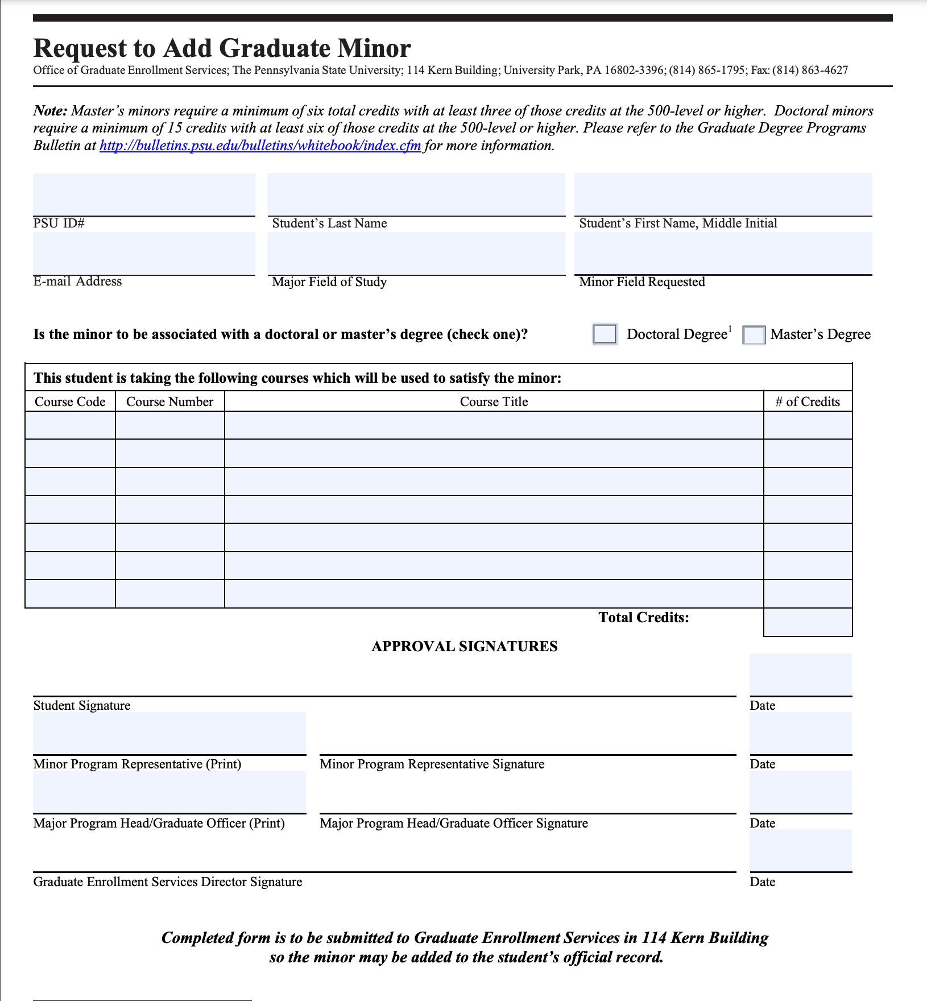

APPENDIX E: ACADEMIC CENTERS OF INTEREST

Given the interdisciplinary nature of our work, it is useful to be award of the great number of non-departmental research units. There are the ones located within the College of the Liberal Arts (https://la.psu.edu/academics/centers-institutes)

- African Feminist Initiative
- Africana Research Center
- Center for Advanced Language Proficiency Education and Research
- Center for American Literary Studies
- Center for Global Studies (Title VI National Resource Center)
- Center for Global Rights
- Center for Human Evolution and Diversity
- Center for Humanities and Information
- Center for International Human Resource Studies
- Center for Language Acquisition
- Center for Language Science
- Center for Social Data Analytics
- Child Study Center
  - Criminal Justice Research Center
- English for Professional Purposes Intercultural Center
- George and Ann Richards Civil War Era Center
- Humanities Institute
- Institute for Korean Studies
- The McCourtney Institute for Democracy
- Rock Ethics Institute
- World in Conversation Lab

Other Department Centers and Organizations

- Center for Global Workers Rights (Labor and Employment Relations)
- Center for International Human Resource Studies (Labor and Employment Relations)
- Center for Research on English Language Learning and Teaching (Applied Linguistics)
- Center for Research on International Financial and Energy Security (Economics)
- Center for the Study of Auctions, Procurement, and Competition Policy (Economics)

- Committee for Early Modern Studies (History, English, Art History)
- Max Kade German-American Research Institute (German and Slavic Languages and Literatures, and History)
- Matson Museum of Anthropology (Anthropology)
- Psychological Clinic (Psychology)

University Interdisciplinary Institutes of Possible Interest:

  - Penn State Cancer Institute
  - Clinical and Translational Science Institute
  - Institute for Computational and Data Sciences
  - Institutes of Energy and the Environment
  - Huck Institutes of the Life Sciences
  - Materials Research Institute
  - Social Science Research Institute
  - Applied Research Laboratory
  - The Sustainability Institute

Appendix F: “THE RED FOLDER”: RESOURCES FOR THOSE NEEDING HELP
